Description on how to download Historical EOD data from Inversor Global:

Stock data from the InversorGlobal website is available at:
http://www.inversorglobal.com.ar/cotizaciones/accionesLideres

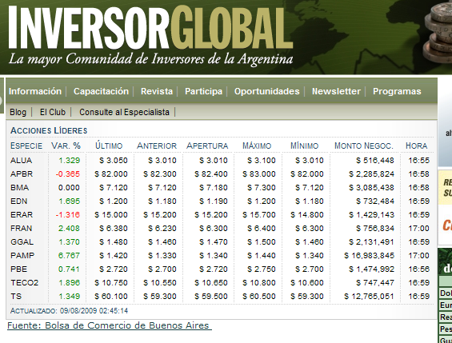

Set-up:

- Copy the following line and append to your existing “mywebserver.txt”, or simply substitute with the attached “mywebserver.txt”.

InversorGlb_D,http://www.inversorglobal.com.ar/cotizaciones/accionesLideres,DL3,InversorGlb_DL3.fmt

The fmt file has set “myRenewTickers” to “1” to refresh ticker symbols, and so you can leave the Tickers list blank (as shown below). However, you may want to change it to “0” if you want to use your own ticker list or the list does not require daily update.

- Copy the “InversorGlb_DL3.fmt” file to the “fmt” subfolder.
- Run HSQuote Plus and set up “InversorGlb_D.tic” as shown.

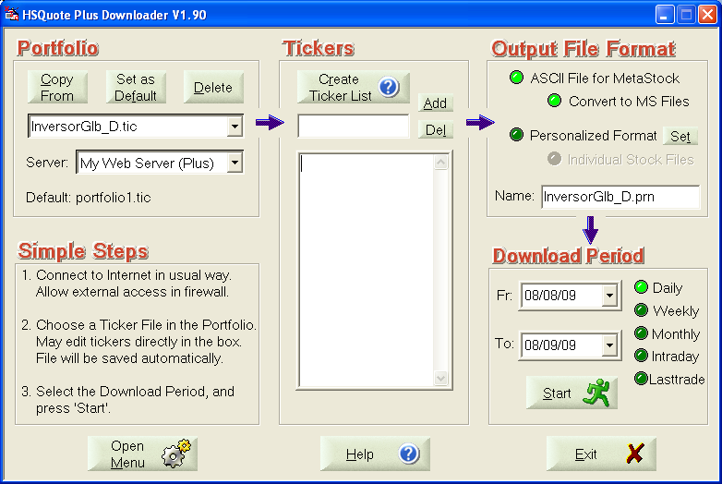

Historical Daily Data Download:

You may use Daily or Lasttrade to download daily data. Note that you will need to at least download the last day data before the web page updates to the next day data. Otherwise, the last day data no longer exists for download.

